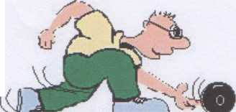

HIGH KELLING SHORT MAT BOWLS CLUB

News News News News News News News _________________________________________________

April Meet & Greet

The meet & Greet event is held twice a year and is designed as a fun event for the short mat club members.

This time there were 8 teams, each of 3 bowlers, playing against each other.

The team with the highest total points from the afternoons bowling wins and each member receives a medal and a prize. The team with the lowest overall points total is awarded the coveted ‘booby’ prize. In the event of a points tie then total ends won are taken into account.

Refreshments are served continuously during the afternoon consisting of tea and coffee together with a sumptuous array of homemade cakes and savouries kindly donated by club members.

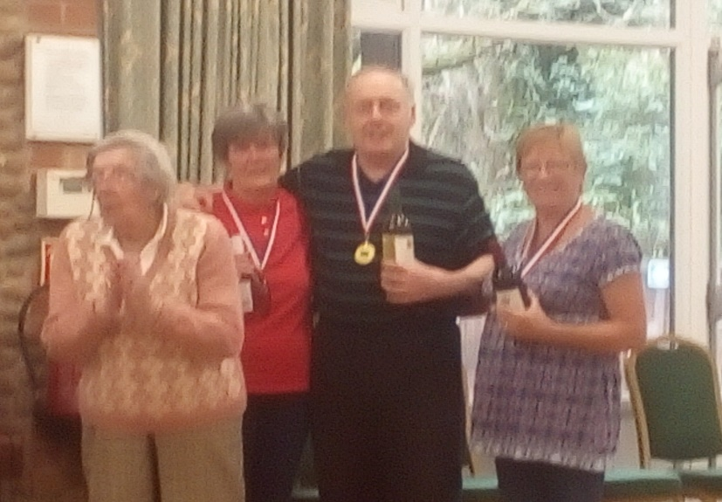
The winners this time were:

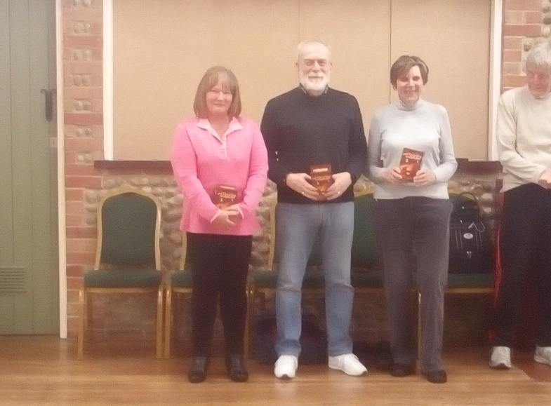
Peter Pazda, Nicola McIntyre and Lyn Baguley (shown with chairman Alice Boon)

The ‘Boobies’ were: Dave Buckley, Debbie Fraser and Janet Garnett.

The day was a great success - Look out for the next meet and greet event to be held October.

